
Applied Science Summer Assignment – Cell Organelles
Aim: Research two cell organelles and prepare a presentation on their structure and function to share with the class in September.
Guidelines:
- Choose two cell organelles and complete research about them
  - Use websites such as
    - http://www.wisegeek.com/
    - http://www.s-cool.co.uk/a-level/biology/cells-and-organelles
    - http://www.a-levelnotes.co.uk/biology-aqa-as-notes-cells-structure-of-eukaryotic-cells.html
    - http://thealevelbiologist.co.uk/cells-2/structure-of-eukaryotic-cells/
  - Remember to include references to your sources
- Prepare a short presentation about your chosen organelles to include the following:
  - Name
  - Diagram
  - Electron micrograph image
  - Where it is found
  - Size
  - Brief outline of its structure
  - Brief outline of its function
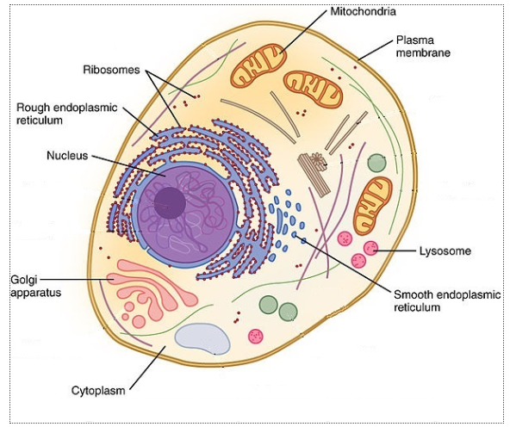
Choose your organelles from
Cell-surface membrane
Nucleus
Mitochondria
Chloroplasts (in plants and algae)
Golgi apparatus
Lysosomes
Ribosomes
Rough endoplasmic reticulum
Smooth endoplasmic reticulum
Cell wall (in plants, algae and fungi)
Cell vacuole (in plants)

GCSE REVISION
- You will also be given an assessment during you first lesson so make sure that you have revised your GCSE biology before the end of the summer. You can log into http://senecalearning.com and join class: zthv5nis2b then complete the GCSE review assignment as part of your revision.

