English Literature AS
Summer Work 2026
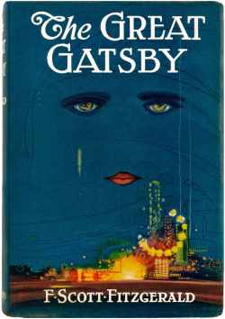
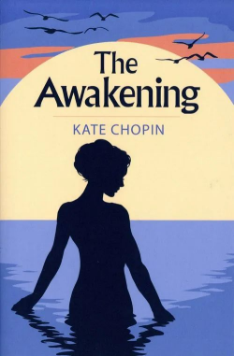
Read F Scott Fitzgerald’s The Great Gatsby and
Kate Chopin’s The Awakening.
These texts will be taught as a comparison,
starting with Gatsby in September.
Have a notebook on hand as you read.
Use this to complete a reading record for each
novel.
Focus on: setting, characters, plot, themes.
Start building a quotation bank for each novel.

